Lab Experiments
S. V. K. Sharon Surya
192324246
Exp: 1- 10

- Write a Pandas program to select the distinct department id from employee’s file.

Aim
To read the employees dataset and display the unique department IDs using Pandas.
Procedure
- Import the Pandas library.
- Load the employees CSV file into a DataFrame.
- Access the DEPARTMENT_ID column.
- Use the unique() method to obtain distinct department IDs.
- Display the unique department IDs.
Code:
import pandas as pd
df = pd.read_csv("departments.csv")
print("Distinct Department IDs:")
print(df["DEPARTMENT_ID"].drop_duplicates())

Output
Distinct Department IDs:
0 10
1 20
2 30
3 40
4 50
5 60
6 70
7 80
8 90
9 100
10 110
11 120
12 130
13 140
14 150
15 160
16 170
17 180
18 190
19 200
20 210
21 220
22 230
23 240
24 250
25 260
26 270
Name: DEPARTMENT_ID, dtype: int64
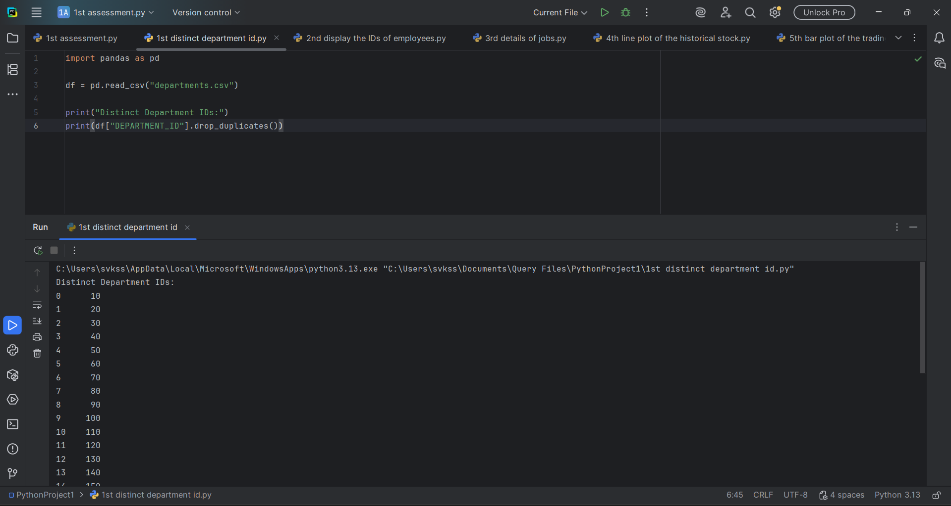

Result
Thus, the distinct department IDs were successfully displayed using the Pandas library.

2.Write a Pandas program to display the IDs of employees who have done two or more jobs in the past.

Aim
To identify employees who have worked in two or more jobs using the job history dataset.
Procedure
- Import the Pandas library.
- Load the job history CSV file.
- Group the data by employee ID.
- Count the number of job records for each employee.
- Display employee IDs having two or more jobs.

Code:
import pandas as pd
df = pd.read_csv("job_history.csv")
count = df.groupby("EMPLOYEE_ID").size()
result = count[count >= 2]
print("Employees with two or more jobs:")
print(result.index.tolist())

Output:
Employees with two or more jobs:
[101, 176, 200]

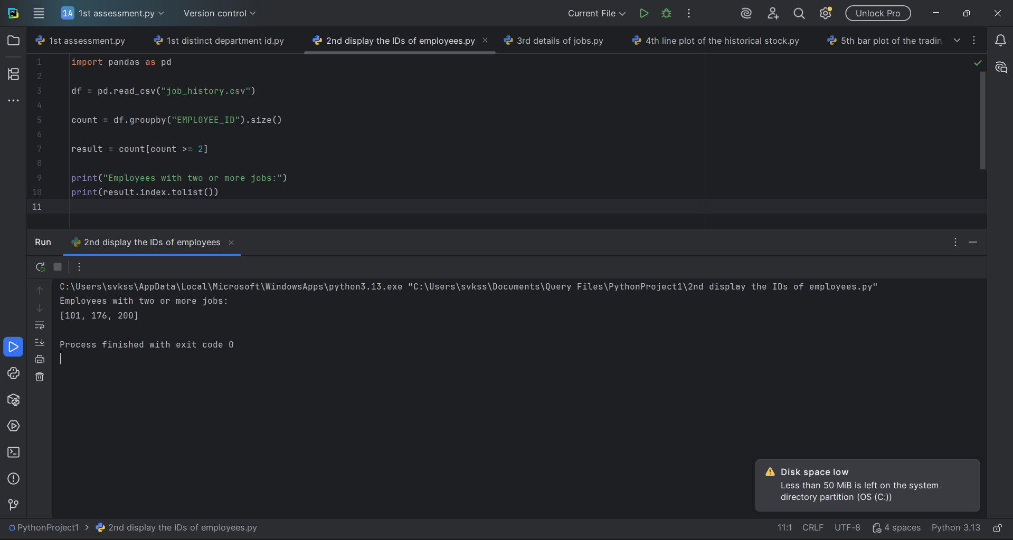

Result
Thus, employees who have worked in two or more jobs were successfully identified.

- Write a Pandas program to display the details of jobs in descending sequence on job title.

Aim
To sort and display the job details in descending order based on the job title.
Procedure
- Import the Pandas library.
- Load the jobs dataset.
- Sort the DataFrame using the JOB_TITLE column in descending order.
- Store the sorted data.
- Display the sorted job details.

Code:
import pandas as pd
df = pd.read_csv("jobs.csv")
result = df.sort_values(by="JOB_TITLE", ascending=False)
print(result)

Output:
JOB_ID JOB_TITLE MIN_SALARY MAX_SALARY
11 ST_MAN Stock Manager 5500 8500
12 ST_CLERK Stock Clerk 2008 5000
13 SH_CLERK Shipping Clerk 2500 5500
8 SA_REP Sales Representative 6000 12008
7 SA_MAN Sales Manager 10000 20080
9 PU_MAN Purchasing Manager 8000 15000
10 PU_CLERK Purchasing Clerk 2500 5500
18 PR_REP Public Relations Representative 4500 10500
6 AC_ACCOUNT Public Accountant 4200 9000
14 IT_PROG Programmer 4000 10000
0 AD_PRES President 20080 40000
16 MK_REP Marketing Representative 4000 9000
15 MK_MAN Marketing Manager 9000 15000
17 HR_REP Human Resources Representative 4000 9000
3 FI_MGR Finance Manager 8200 16000
1 AD_VP Administration Vice President 15000 30000
2 AD_ASST Administration Assistant 3000 6000
5 AC_MGR Accounting Manager 8200 16000
4 FI_ACCOUNT Accountant 4200 9000

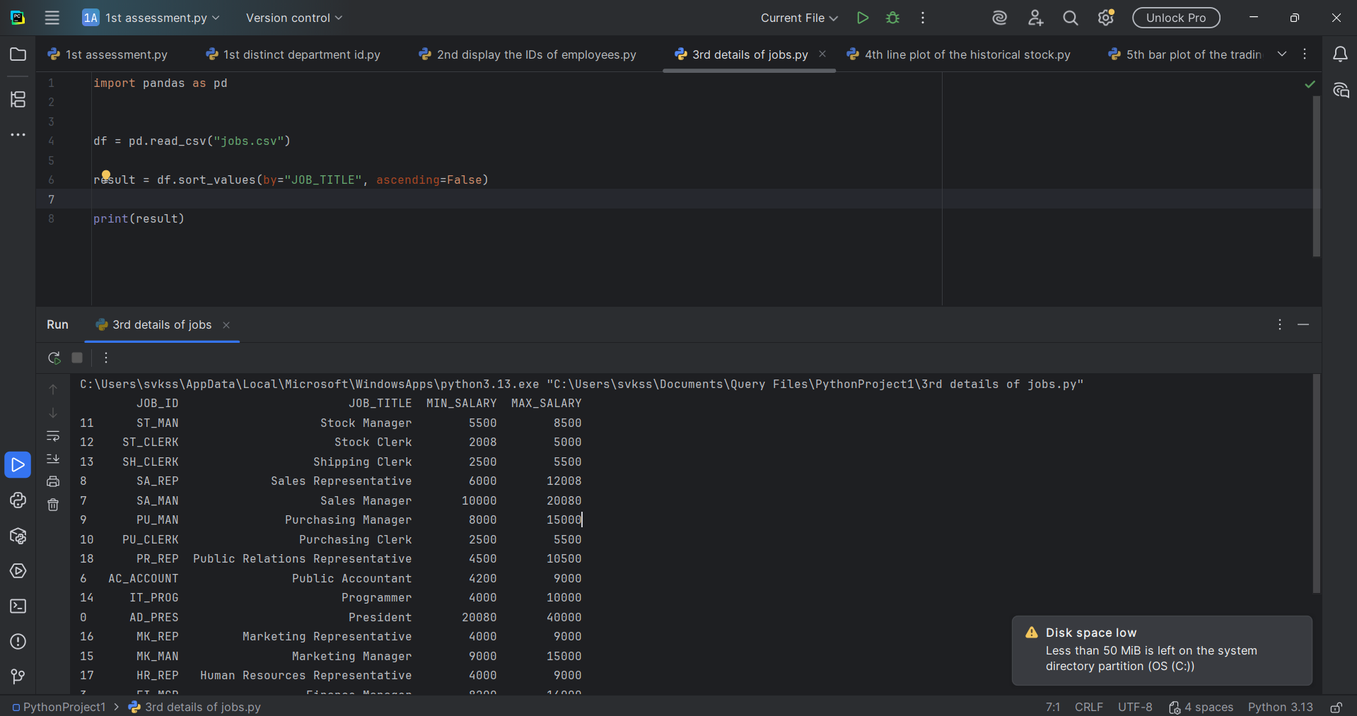

Result
Thus, the job details were successfully displayed in descending order of job title.

- Write a Pandas program to create a line plot of the historical stock prices of Alphabet Inc. between two specific dates.

Aim
To visualize the historical stock prices of Alphabet Inc. using a line plot.
Procedure
- Import Pandas and Matplotlib libraries.
- Load the Alphabet stock price dataset.
- Filter the data between the specified dates.
- Plot the closing stock prices as a line graph.
- Display the graph with title and axis labels.

Code:

import pandas as pd
import matplotlib.pyplot as plt
df = pd.read_csv("microsoft_stock_prices_2016_2026_refined.csv")
df["Date"] = pd.to_datetime(df["Date"])
start_date = "2020-01-01"
end_date = "2020-12-31"
filtered = df[(df["Date"] >= start_date) & (df["Date"] <= end_date)]
plt.figure(figsize=(10,5))
plt.plot(filtered["Date"], filtered["Close"], color="blue")
plt.title("Alphabet Inc. Stock Closing Price")
plt.xlabel("Date")
plt.ylabel("Closing Price")
plt.xticks(rotation=45)
plt.grid(True)
plt.show()

Output:
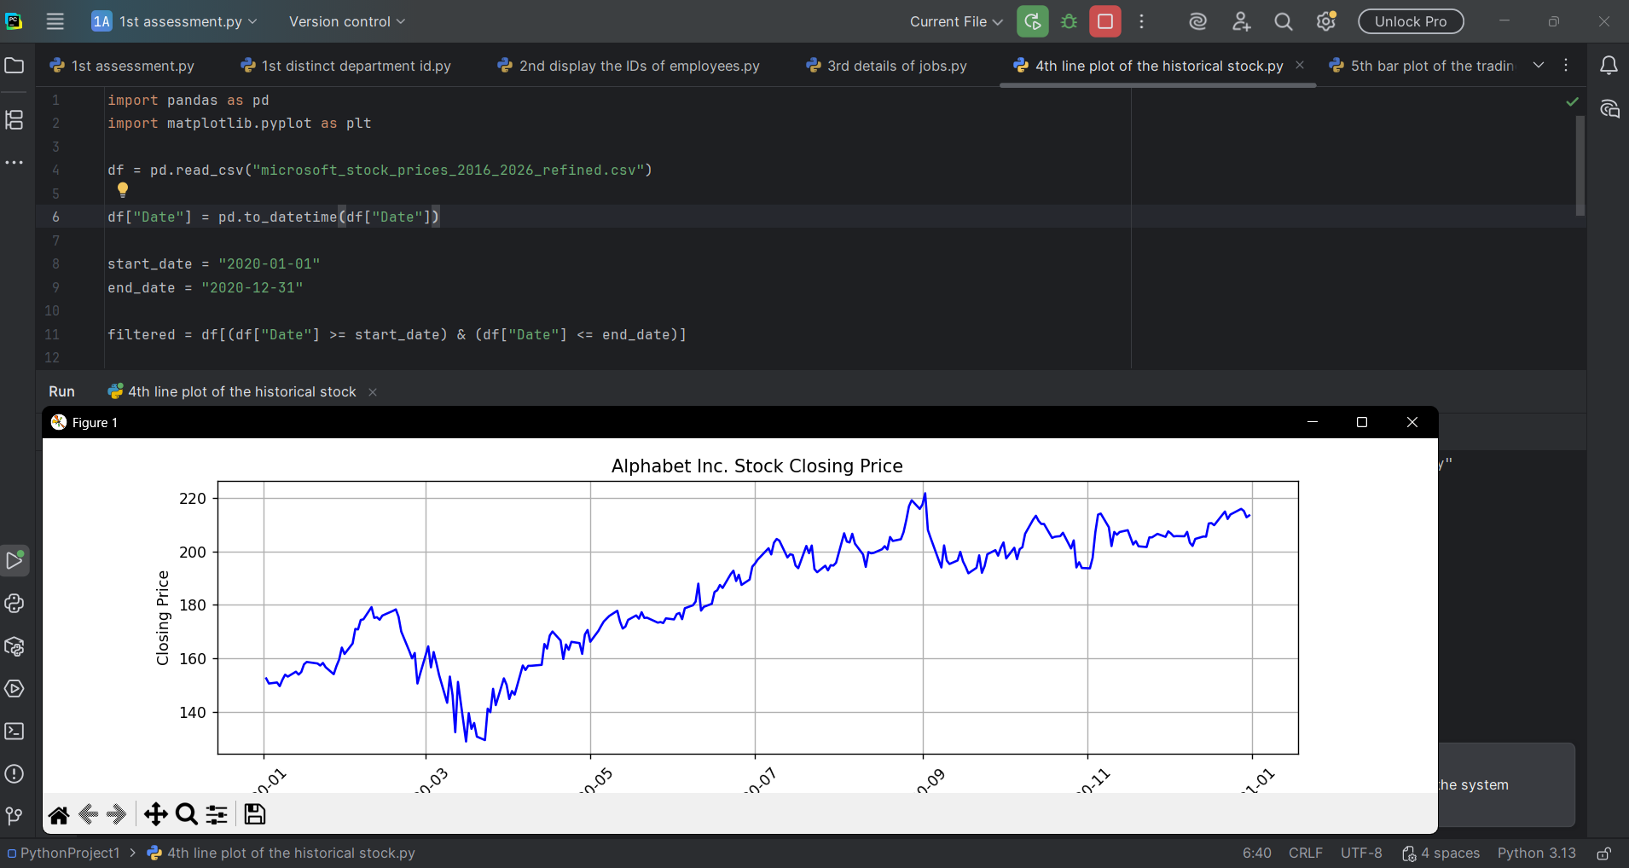

Result
Thus, the historical stock prices of Alphabet Inc. were successfully visualized using a line plot.

- Write a Pandas program to create a bar plot of the trading volume of Alphabet Inc. stock between two specific dates.

Aim
To visualize the trading volume of Alphabet Inc. stock using a bar plot.
Procedure
- Import Pandas and Matplotlib libraries.
- Load the Alphabet stock dataset.
- Filter the records between the specified dates.
- Create a bar plot using the trading volume data.
- Display the graph with appropriate title and labels.

Code:
import pandas as pd
import matplotlib.pyplot as plt
df = pd.read_csv("microsoft_stock_prices_2016_2026_refined.csv")
df["Date"] = pd.to_datetime(df["Date"])
start_date = "2020-01-01"
end_date = "2020-12-31"
filtered = df[(df["Date"] >= start_date) & (df["Date"] <= end_date)]
plt.figure(figsize=(12,5))
plt.bar(filtered["Date"].dt.strftime("%Y-%m-%d"), filtered["Volume"])
plt.title("Alphabet Inc. Trading Volume")
plt.xlabel("Date")
plt.ylabel("Trading Volume")
plt.xticks(rotation=90)
plt.tight_layout()
plt.show()
Output:
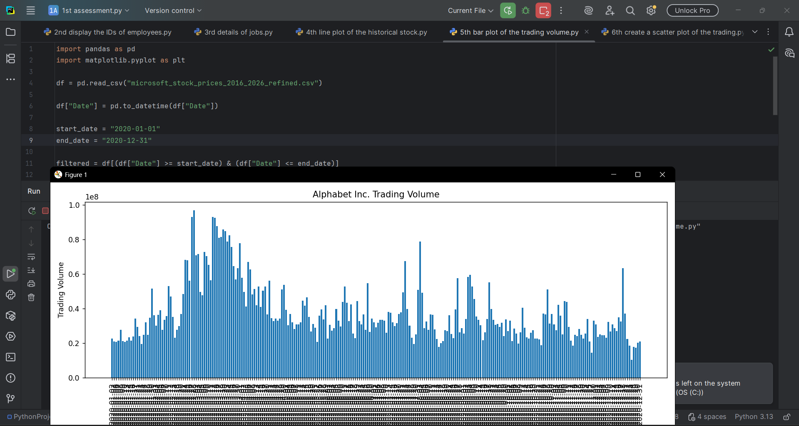

Result
Thus, the trading volume of Alphabet Inc. stock was successfully represented using a bar plot.

- Write a Pandas program to create a scatter plot of the trading volume/stock prices of Alphabet Inc. stock between two specific dates.

Aim
To visualize the relationship between trading volume and stock prices of Alphabet Inc. using a scatter plot.
Procedure
- Import the Pandas and Matplotlib libraries.
- Load the Alphabet Inc. stock dataset.
- Filter the records between the specified dates.
- Plot the trading volume against the stock prices using a scatter plot.
- Display the graph with suitable title and axis labels.

Code:
import pandas as pd
import matplotlib.pyplot as plt
df = pd.read_csv("microsoft_stock_prices_2016_2026_refined.csv")
df["Date"] = pd.to_datetime(df["Date"])
filtered = df[
(df["Date"] >= "2020-04-01") &
(df["Date"] <= "2020-05-01")
]
plt.figure(figsize=(10,6))
plt.scatter(filtered["Volume"], filtered["Close"])
plt.title("Trading Volume vs Closing Stock Price")
plt.xlabel("Trading Volume")
plt.ylabel("Closing Stock Price")
plt.grid(True)
plt.show()

Output:

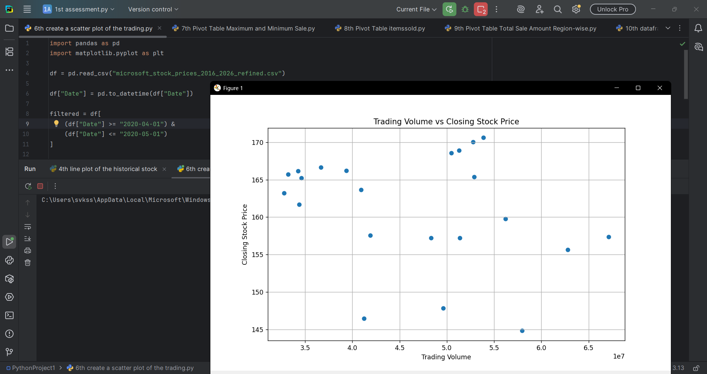

Result
Thus, the relationship between trading volume and stock prices of Alphabet Inc. was successfully visualized using a scatter plot.

7. Write a Pandas program to create a Pivot table and find the maximum and minimum sale value of the items. (Refer sales_data table.)

Aim
To create a Pivot table and determine the maximum and minimum sale values of each item.
Procedure
- Import the Pandas library.
- Load the sales_data dataset.
- Create a Pivot table using the item name as the index.
- Apply the maximum and minimum aggregation functions on the sale amount.
- Display the Pivot table.

Code:
import pandas as pd
# Read CSV
df = pd.read_csv("sales_data.csv")
# Pivot Table
pivot = pd.pivot_table(
df,
values="Sale_amt",
index="Item",
aggfunc=["max", "min"]
)
print("Maximum and Minimum Sale Amount of Items")
print(pivot)

Output

max min
Sale_amt Sale_amt
Item
Cell Phone 14400 6075
Desk 250 250
Home Theater 40500 14000
Television 113810 38336
Video Games 936 936
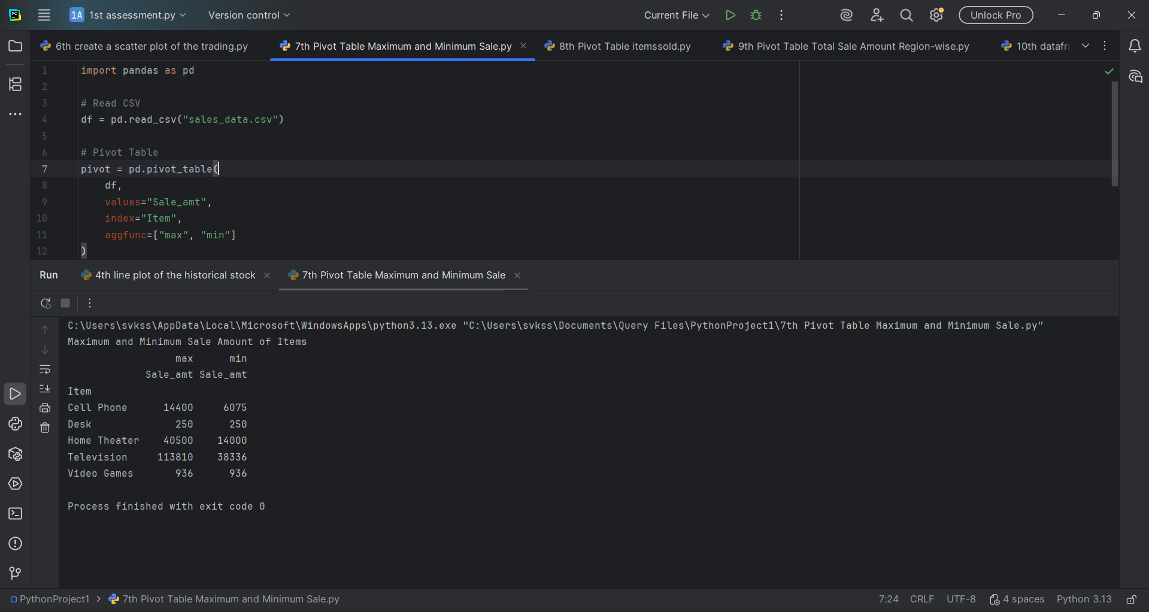

Result
Thus, the maximum and minimum sale values of each item were successfully obtained using a Pivot table.

8. Write a Pandas program to create a Pivot table and find the item-wise units sold.
Aim
To create a Pivot table and calculate the total units sold for each item.
Procedure
- Import the Pandas library.
- Load the sales_data dataset.
- Create a Pivot table using item names as the index.
- Sum the units sold for each item.
- Display the Pivot table.
Code:
import pandas as pd
# Read CSV
df = pd.read_csv("sales_data.csv")
# Pivot Table
pivot = pd.pivot_table(
df,
values="Units",
index="Item",
aggfunc="sum"
)
print("Item-wise Units Sold")
print(pivot)

Output:
Item-wise Units Sold
Units
Item
Cell Phone 91
Desk 2
Home Theater 308
Television 509
Video Games 16

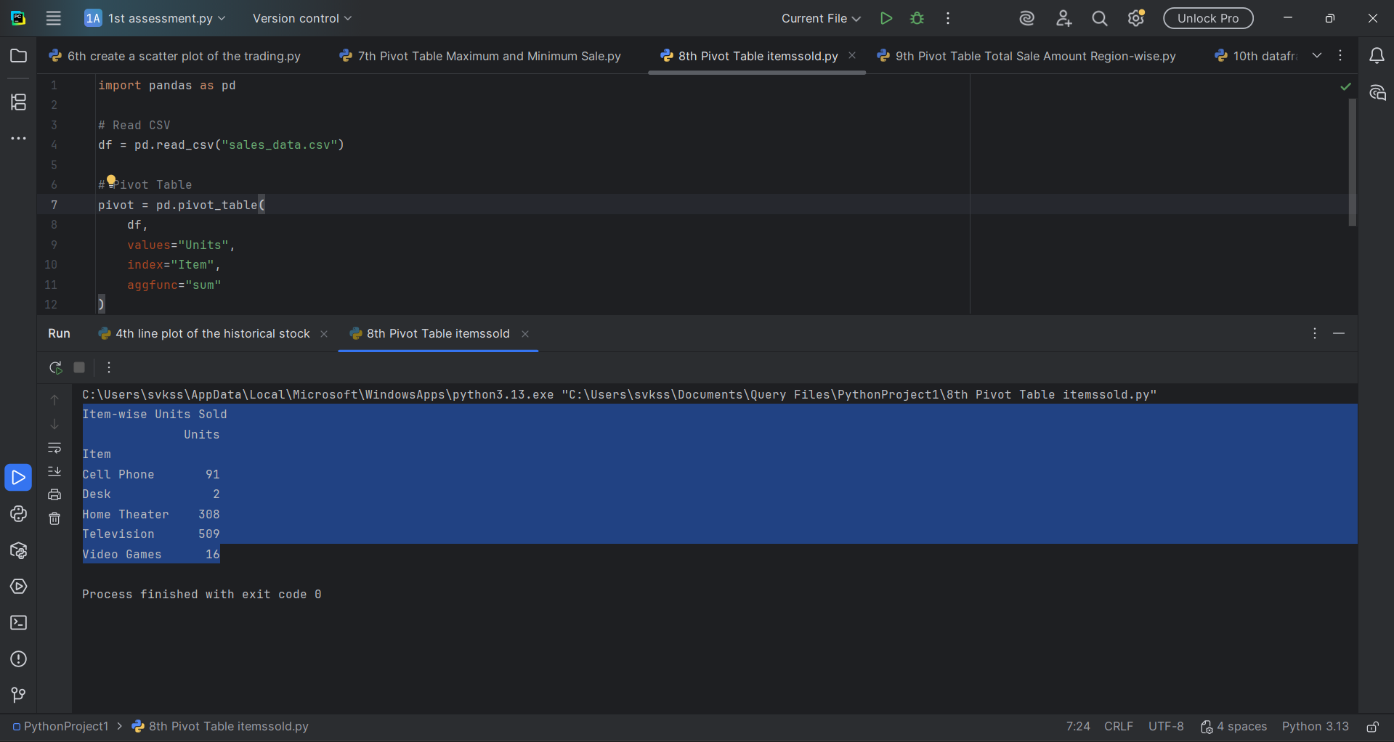

Result
Thus, the item-wise total units sold were successfully calculated using a Pivot table.

9. Write a Pandas program to create a Pivot table and find the total sale amount region-wise, manager-wise, and salesman-wise.

Aim
To create a Pivot table and calculate the total sale amount based on region, manager, and salesman.
Procedure
- Import the Pandas library.
- Load the sales_data dataset.
- Create a Pivot table using Region, Manager, and Salesman as indexes.
- Calculate the total sale amount using the sum function.
- Display the Pivot table.
Code:
import pandas as pd
df = pd.read_csv("sales_data.csv")
pivot = pd.pivot_table(
df,
values="Sale_amt",
index=["Region", "Manager", "SalesMan"],
aggfunc="sum"
)
print("Total Sale Amount")
print(pivot)

Output:

Total Sale Amount
Sale_amt
Region Manager SalesMan
Central Douglas John 250
Hermann Luis 150948
Shelli 25000
Sigal 121820
Martha Steven 89850
Timothy David 6075
East Douglas Karen 40500
Martha Alexander 231076
Diana 14500
West Douglas Michael 38336
Timothy Stephen 67088

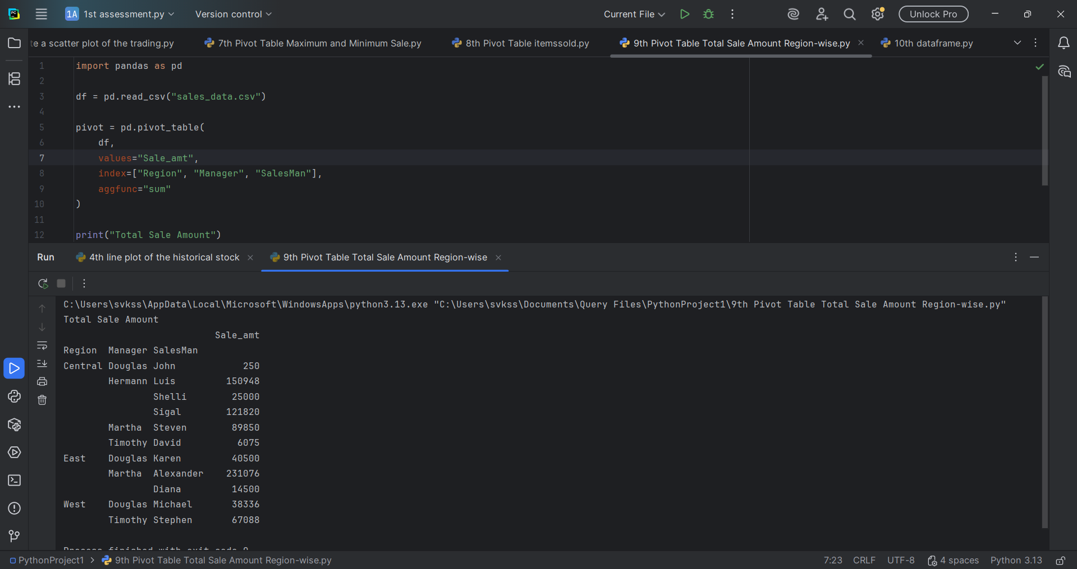
Result
Thus, the total sale amount was successfully calculated region-wise, manager-wise, and salesman-wise using a Pivot table.

10. Create a DataFrame of ten rows and four columns with random values. Write a Pandas program to highlight the negative numbers in red and positive numbers in black.

Aim
To create a DataFrame with random values and apply conditional formatting to highlight negative values in red and positive values in black.
Procedure
- Import the Pandas and NumPy libraries.
- Generate a DataFrame with ten rows and four columns of random values.
- Create a styling function to assign colors based on the value.
- Apply the styling function to the DataFrame.
- Display the formatted DataFrame.
Code:
import pandas as pd
import numpy as np
# Create DataFrame
np.random.seed(10)
df = pd.DataFrame(np.random.randn(10,4), columns=['A','B','C','D'])
print(df)
Output:

A B C D
0 1.331587 0.715279 -1.545400 -0.008384
1 0.621336 -0.720086 0.265512 0.108549
2 0.004291 -0.174600 0.433026 1.203037
3 -0.965066 1.028274 0.228630 0.445138
4 -1.136602 0.135137 1.484537 -1.079805
5 -1.977728 -1.743372 0.266070 2.384967
6 1.123691 1.672622 0.099149 1.397996
7 -0.271248 0.613204 -0.267317 -0.549309
8 0.132708 -0.476142 1.308473 0.195013
9 0.400210 -0.337632 1.256472 -0.731970

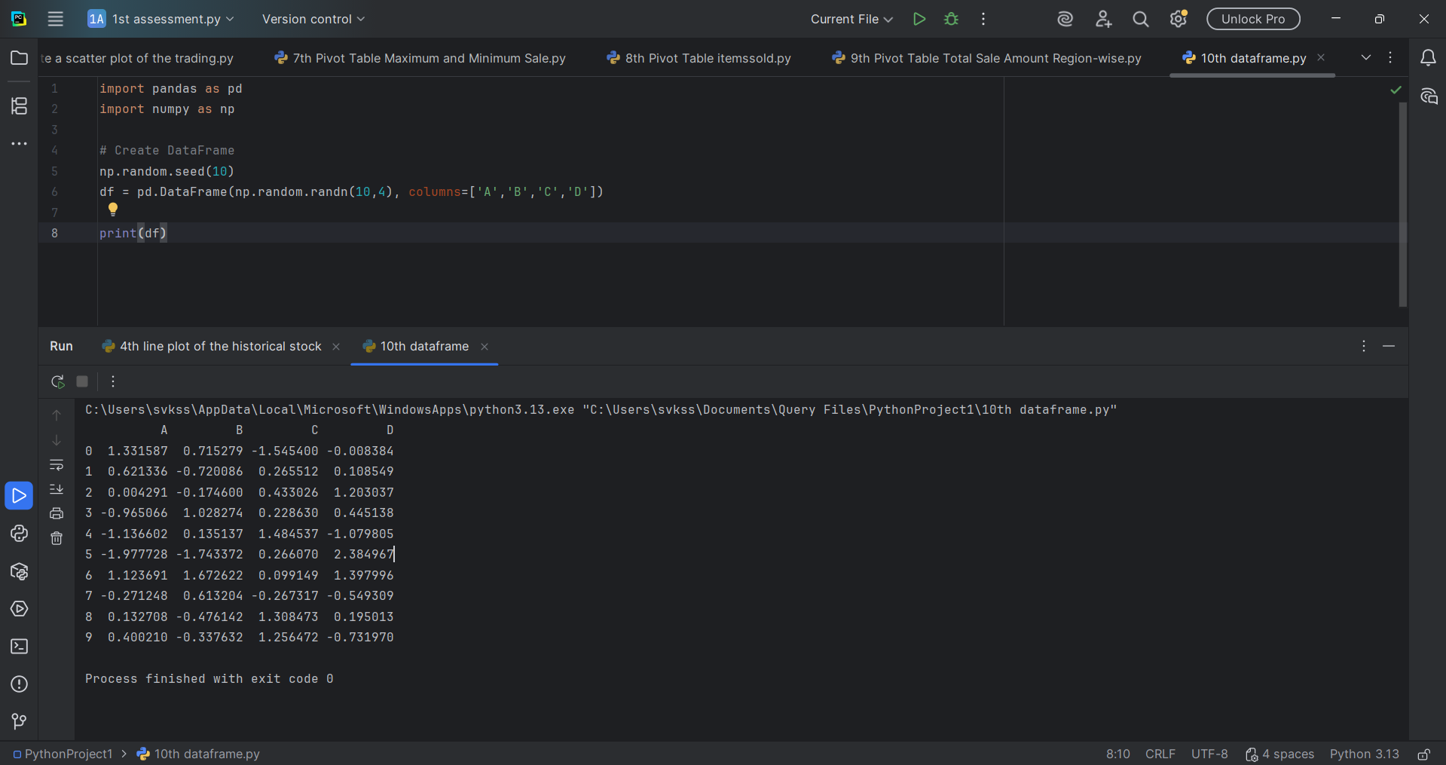

Result
Thus, the DataFrame was successfully created, and conditional formatting was applied to highlight negative values in red and positive values in black.

